Angular is used for single-page applications

Understanding Angular Versioning

-Angular doesn’t change in different versions
-AnularJS or Angular1 had many issues and it is rewritten because of the issues in bigger applications
-Angular 2 is released 2016 and since then new version is released every 6 months. Changes are minor and angular 2 is almost identical to the latest version of Angular (9 at the time of the video)

-Creating new project with ng
-starting local server with ng serve
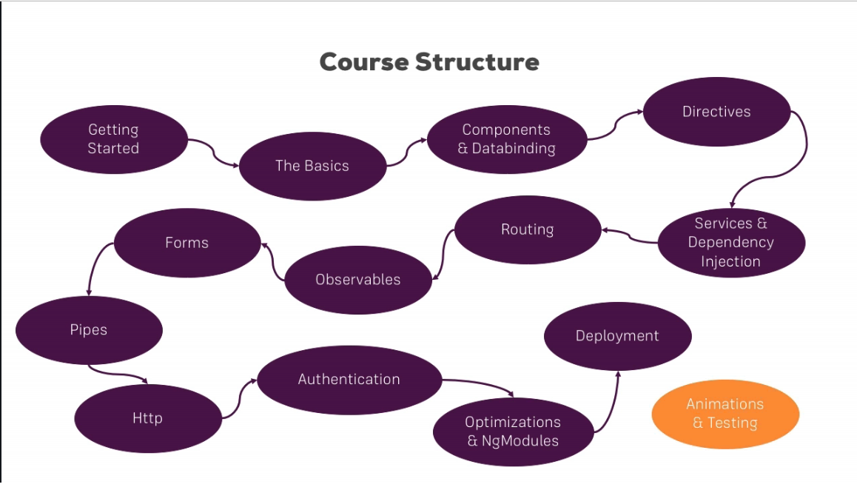
What is the Type script

-Type Script is super-set of JS. It offers more features then vanilla Java Script , like classes , interfaces and very important strong typing.
-You define in TypeScript if a certain variable is a number a string or something else
-In vanilla JS you can have a variable holding a string and you can assign a number to that variable. In TS you would get an error trying to do the same thing
-Because of the strong typing code is checked at the time of the writing not just at the time of the running
-TS is not running in the browser and it is compiled to JS at the end
-Compilation is done by the CLI and it is very fast
-A lot of features really only exist in Type-script and Angular is meant to be used together with TS
-TS is an addition to JS not a complete replacement

Setting Bootstrap for the project

-Installation of the Bootstrap | npm install –save bootstrap@3
-changing angular.json file to configure the usage of new installed bootstrap
-one component is already there by default and that is to use styles.css for global css stilling.
-adding “node_modules/bootstrap.dist/css/bootstrap.min.css” to include bootstrap
-whenever the configuration is changed ng serve must be run to load different configuration
How an Angular App gets Loaded and Started

-File actually served by the server is index.html and the same file represents the single page application which is served
-CLI created first root component which is going to tie the whole application at the end. All the files inside app folder with the component in their name are related to the component which is loading
-selector inside .ts is the name of the component which was used inside of the index.html
-In the final file (the one running in the browser) at the end of the file there are script imports automatically added by CLI. These script imports are run first and they are all inside of the main.ts file
- this line from main.ts platformBrowserDynamic().bootstrapModule(AppModule); bootstraps (starts) boostrap application by passing AppModule to this method. AppModule refers to the file app/app.module.ts
-After that in the line bootstrap:[AppComponent] , app.module is pointing to the all files above referring to all of them as AppComponent
-Angular analyzes the app component reads the setup we pass and therefore knows selector <app-root>. After that Angular is able to handle app-root in the index.html
Because the AppComponent is listed in the array in the app.module
-Therefore Index.html knows that there is <app-root> and reads the html from that file

Components are important

-Angular in the end is a JS framework changing your DOM(‘HTML’) at runtime!
-Components are a key features in Angular. You are building your whole application by composing it from a couple of components which you create on your own
-We are starting from app component which holds our entire application
-The root component will be the component where we are going to nest or add our other components

-header of the website is good candidate for the new component
-there is also main area and sidebar as a component and that is the core idea behind Angular. Each component as its own template , its own HTML code maybe own styling and more importantly it’s own business logic.
-Angular is allowing you to split up your complex website into reusable parts.
-It is possible to use component multiple times and that allows you to easily replicate business logic
-it is very easy to update , exchange and reuse

Creating a New Component

-AppComponent is in the same time normal and special component because it serves as root component
-All App related content will go into the app folder (Server is the name in the project because it holds Server Component)
-ts extension at the end of the file means type script
-component is just a class Type script class. And Angular is able to instantiate it to create objects based on the blueprint we set up
-that new class has to be exported in order to be used in different places
-To notify the Angular engine about the nature of the class (that this is new component class) we have to add decorator @. Decorators in Angular are used to enhance the classes @Component
-Component is not something that TypeScript knows from the start so we have to import
-We have to add an import.(Import is inside of the curly braces because we can import something else also) After the import we have access to the component
-package from which we import component is from @angular/core
-Angular ships with a couple of packages where it basically groups its functionalities and the core package gives us access to some of the core functionalities of Angular
-We have to configure the imported decorator. We are passing the Java Script object to configure @Component({...here...})
-all the information inside of the configuration will be stored as metadata for this class and it will tell Angular what to do with this class
-first metadata we are writing is selector (which is the string and should be unique) “app-server” (name starts with app- )
-second metadata is templateURL: ‘./server.component.html’ (relative path)
-server.comonent.html file is also created in the same folder

Understanding the Role of AppModule and Component Declaration

-Angular uses components to build web pages and uses modules to basically bundle different pieces together ,for example components of your app into packages
-for bigger projects we can split app module into multiple modules but for the most of the projects using only one app module it’s perfectly fine
-In order to use the new created component server.component.ts we have to change app.module.ts
-Module in general is bundle of functionalities of our app (entire app if module is not split) and it basically gives Angular the information which feature does my app have and use
-It is also an empty TypeScript class which we are transforming into something else by adding a decorator. In he app.module it’s @NgModule
-for the configuration we are passing declarations , imports , provides , bootstrap
-We have to register the new created component server.component.ts inside of the app.module.ts. Angular is not scanning all the files by default. If the file is not registered the server doesn’t know that the component exist. Just creating the file is not enough
-Registration is done inside of the decorator @NgModule inside of the declarations: [
AppComponent,
ServerComponent
]

-We have to import also at the top of the app.module file
import { ServerComponent } from ‘./server’/server.component’;
Because TypeScript also needs to know where is the component
Important to know here is that we don’t add .ts at the end of the file. The extension is added by the webpack which bundles our project automatically
-After the registration and import we can use our component
-inside imports: configuration it is possible to split the module and outsource some stuff into another module
Because Angular itself is split up into modules we have to import some modules here inside imports:

Using custom components

<app-server></app-server>

Creating Components with the CLI/Nesting Components

-CLI commands can be used also to create new component
ng generate component servers
ng g c servers

-component can be used as many times as selector is used in code
-When the component is registered in app.module.ts it can be used anywhere in the code

Working with Component templates

-Instead of using an external template file , you can also use an inline template which means you define the HTML code in the Type Script code
-If it is defined internally we are configuring the decorator with template not templateURL
-template : “<app-server></app-server><app-server></app-server>”

-It is possible to use `` backtiks and write html code inside of the template.
If you don’t have much code using an inline template like this might be fine then you have logic in the Type Script code and that is ok. But as soon as you have more than 3 lines of code using an external file is good idea to make it easier to follow and easier to understand
-It is possible to omit the selector and style (in the routing there is a different way of loading components) but template must be present

Working with Component styles

-css code is inside of the css style for that component
-also we can chose between style (this is inline style) and styleUrls(external)
-s the end of the styleUrls means that you can add multiple style-sheets
-you can’t combine both

Fully understanding Component Selector

-selector: (in decorator) is working as css selector it is the same style
selector:’app-servers’ so you are not limited to selecting by element
-if you select by attribute selector: ‘[app-servers]’ then you have to change the way you show the template
<div app-server></div> ( there is a custom attribute in this case)
-selecting by id,pseudo-selectors,hover... is not supported by Angular
-typically element styles are used for components

What is Databinding

-Databinding = Communication
-Communication between your TypeScript code of your component, your business logic and the template
-Some result in Type Script code can be from the Data Base or from some calculation. That result can be shown to the user dynamically

-showing data from Type Script code to HTML in the template
output data:
string interpolation {{ data }}
property binding [property] = “data”

-React to User Events
(event) = “expression”

-combination of both: Two Way Binding
[(ngModel)] = “data”

String interpolation

- {{ }} Type Script expression goes inside

String interpolation has to return a string at the end or something that can be converted to string. It can be a method also and ternary expression can be used

Restrictions are: no multi-line , block expressions , in , for structures

Property Binding

[ disabled ] = “!allowNewServer” (from example)(we are binding to html element properties. Any property)
-there are many situations where you can ether use property binding or string interpolation
-constructor is the method which is executed at the time when the component is created by Angular (constructor is inside of that component)
-using two way binding the data is dynamic and it changes when data changes
-one of the main reasons why you use Angular because it makes very easy for you to interact with DOM.
Property binding vs String interpolation

<p [innerText] = “allowNewServer”></p>

you can add property like this (data binding to the property of the tag)
-If you want to output something in your template , print some text to it, use string interpolation
-If you want to change some property of a HTML element or a directive of the component use property binding
-string interpolation and property binding should not be mixed (inside of eachother)
-String interpolation works only inside of the normal template not inside of other expression
-Syntax for property binding is built into Angular and it is recognized by the Angular

Event Binding

- (click)= “” all event binding events are written like this inside () without on in onclick
-It is possible to write code inside of the “” but often it is not practical (usually we write a lot of code there)
-for example if there is a need to setup the Boolean value then it is recommended to write code inside
-How do you know which Properties or Events of HTML Elements you may bind? You basically bind to all Properties and Events –a good idea is to console.log() the element you’re interested in to see which properties and events it offers

Important: For events , you don’t bind to onclick but only to click(=> (click))

The MDN offers nice list of all properties and events of the element you’re interested in. Googling for YOUR_ELEMENT properties or YOUR_ELEMENT event should yield nice results

Passing and Using Data with Event Biding

-for click and input there is a special feature. You can pass $event as an argument of the method called between the quotation marks
-$event will be the data emitted with that event
-input and click are default events provided by the DOM and they ship some data when they are fired.
Click event gives us an object which for example gives us coordinates of the click event (and many other information's)
-We can capture data because of the $event argument
-$event is the reserved word which gives us the information of the event data

TS TIP || <HTMLInputElement>event.target means that the input element which we are waiting will be of the HTML input element type

important: For Two-Way-Binding(covered in the next lecture) to work , you need to enable ngModel directive. This is done by adding the FormsModule to the imports[] array in the AppModule

You than also need to add the import from @angular/forms in the app.module.ts

import { FormsModule } from ‘@angular/forms’;

Two Way Data Binding

-Enabling the ngModel will trigger the input event and update the value of text inside the input field automatically
-Data binding works the same way but with ngModel we have two way binding. If we give some value to the fetched variable value. That value is going to pre populate the input field
-it is a very simple way of binding in both directions and reacting to changes in the input value

Combining all forms of data binding

-in the example we used all four forms of data binding together with each other. Event binding ti listen to the click , string interpolation to output data , property binding to enable click button (after 2 sec it is becoming available) and two way binding to fetch input data

Understanding directives

-directives are instructions in the DOM
-components are kind of such instructions to the DOM because we through the component are instructing Angular to add the content of our component template and the business logic in out TypeScript code in the place where we are using selector
-components are directives with a template
-typically we add directives with an attributes selector
-selector of the directive can be configured like the selector of the component so you could also use CSS classes or the elements style but we typically use attribute style

<p appTurnGreen>Receives a green background</p>

@Directive ({
selector:’[appTurnGreen]’
})
export class TurnGreenDirective {

}

Using ngIf to Output Data conditionally

-ngIf directive is shipped with Angular
-ngIf is added ading the star first *ngIf.The star is required because ngIf is structural directive it changes the structure of our DOM it either adds element to the DOM or it doesn’t
Without the star directive wouldn’t work. Star is just some extra information for the Angular
-Important to understand is that the element is not hidden. Actually it doesn’t exist. It is added to the DOM with the button event

Enhancing the ngIf with an Else condition

-local reference is placed on the ng-template of the else element
-else element is always placed inside of the<ng-template (ng-template is the component which is provided by the Angular which you can use to mark places in the DOM)

<p *ngIf=”serverCreated”; else noServer> Server was created , server name is
{{ serverName }}</p>

<ng-template #noServer>
<p>No server was created!</p>
<ng-template>

-We marked the spot with # and in the statement above we are deciding to show or not that spot depending of the condition

Styling Elements Dynamically with ngStyle

-ngStyle is structural directive. Attribute directive doesn’t add or remove elements. They only change the element they are placed on
-They are written without the star

<p [ngStyle]= “{backgroundColor: getColor()}” ></p>

it is very important to understand that property binding doesn’t have anything to do with directive, square brackets are here because of the binding.
-the advantage of ngStyles is dynamic update of the styles. If in the previous example color changes it would update the color respectively

Applying CSS classes Dynamically with ngClass

-same as for previous example we have to pass an Java Script object
-we also have key , value pairs. The keys are the CSS class names and the values are the conditions determining weather this class should be attached or not

<p [ngClass]="{ online: serverStatus === 'online'}" ></p>

Outputting Lists with ngFor

<app-server *ngFor="let server of servers"></app-server>

-We define a temporary variable inside the loop with let, give it any name you like. Server variable is dynamic and it is taking individual value through each loop.
-server variable is becoming available to be used in template with string interpolation

-we can add extra feature to ngFor. With “let i=...” we have access to the index of current iteration

<app-server <*ngFor=”let server od servers”; let i=index></app-server>

Course project

-build recipe book and shopping list app
-planing
.. first is to layout the structure of the app and plan which components
you’re going to need (latter during development you can change anything)
.. every component should focus on one main topic, displaying a list ,
displaying info about the single item, displaying detail information
about a selected item
.. we have to decide which models will be used in this app.(which data)

-in the project we are creating the model first time
-model is simply a Type Script file which represents the blueprint for future recipes. We use TS to create class. That class is the model

recipes: Recipe[] = [] Type Script knows that only thing which will ever get stored in this property is an array which holds a couple of recipe objects

-we didn’t enable communication between components. Communication will allow us to store content in different component and use that data somewhere else

Understanding Angular Error messages

-Errors are inside of the console
First it is mentioned the class or place of the error and then details line number and than the column.
Next message in the Error is the cause of the error

Debugging Code in the Browser Using Source-maps

-In the Chrome we can access the sources tag inside of the console
-if you click on some line it will automatically jump to that place in the type script file.
-JS files in Angular compiled from TS and they support TS. You can place breakpoints in the TS. That means that the file will run up to the break-point and display information about that place in the code. Then the arrow can be clicked to continue one step forward.
-Type script files can be accessed directly from sources tag also under the web-pack sub-folder

Using Augury to dive into Angular Apps

-It is the third way of debugging. It is a browser extension

UNDERSTANDING COMPONENTS AND DATA-BINDING

Splitting Apps into Components
Property&Event Binding

-We are able to send data into component or receive data. We are receiving that data in the event object
-We can use property binding on

HTML elements Directives Components(our own)

Native properties&events Custom properties&events Custom properties&events

-we can emit our own events

Binding to Custom properties

-By default all properties of components are only accessible inside these components, not from outside
-You have to be explicit about which properties you want to expose
-If you want to allow parent components to be able to bind to this property you need to add decorator to that element property

import { Component, OnInit , Input} from '@angular/core';

@Input() element: {type: string, name: string, content: string};

-Decorator @Input has to be imported from angular core
-We are passing the value from the component above and the example above is showing how to use the value in that component

Parent component is emitting the event
[element] = “ServerElement”

Assigning an Alias to Custom Properties

-It is possible to bind to the Alias of the element you want to bind. Aliasing is for the better clarity in the code. It is passed as argument to decorator

@Input(srvElement) element: {type: string, name: string, content: string};
[‘srvElement’] = “ServerElement”
Binding to Custom Events

-The above example was passing data to the child component
-This example is passing data from the child to the parent

-We are emitting the custom event using eventEmitter.
-EventEmitter is an object in the Angular framework which allows you to emit your own events

-We are outputting event

@Output() serverCreated = new EventEmitter<{ serverName: string, serverContent: string }>();

-That output is called from function which is bind to click event. Information to the @Output is done through emit() function

onAddServer() {
this.serverCreated.emit({
serverName: this.newServerName,
serverContent: this.newServerContent
});
}

-we are waiting the event in the parent element with

<app-cockpit
(serverCreated = “onServerAdded($event)”)
(blueprintCreated) = “onBLueprintAdded($event)”
>
</app-cockpit>

-after the functions are called they are passed to the child element as arguments and binding to child components is activated

Assigning an Alias to Custom Events

-Inside of the output pass the argument which is going to be Alias

Custom property and Event Binding Summary

-Communication between component in the same level is different. They have to communicate with parent component first

Understanding View Encapsulation

-CSS apply only to the component where it is written. That is not default behavior of the browser Angular actually enforces the styles encapsulation
-Angular is adding ngcontent attribute to each component and on that way it is encapsulating
-Angular is creating shadow DOM and it is making changes to that DOM instead of the real DOM. That DOM is supporting encapsulation
-Encapsulation can be overwritten by adding to
@Component
encapsulation: ViewEncapsulation.None (it has to be imported also)

encapsulation: ViewEncapsulation.Native (uses shadow DOM technology )
encapsulation: ViewEncapsulation.Emulated (emulates shadow DOM for older browsers)

-Emulated is default behavior

Using Local References in Templates

-Local reference can be placed on any HTML element
-#serverNameInput referencing the mentioned element after # . This reference is referencing the whole element not just the value (we are using input element in example)

We can pass the reference anywhere we want
… (click) = “onAddServer(serverNameInput)” …
-very important to remember that references can be used only in template not inside of the .ts files
-We are using Local References instead of the two way binding in case we just want to save data and to change data in the template

Getting Access to the Template & Dom with @ViewChild

-if we want to access data before the event
-We are passing the local reference like in the above example (in the HTML)
-inside of the TS file we have to import @ViewChild from angular core

and use as a decorator

@ViewChild(‘serverContentInput’, {static:true}) serverContentinput: ElementRef;
(ElementRef has to be imported also)

now we have access to the

serverContent: this.serverContentInput.nativeElement.value

(serverContent is the value which we are Outputing )

-We can use ViewChild to set value of the element also but there is a much better way of accessing the DOM and it shouldn’t be used

Projecting Content into Components with ng-content

-it is used if you want to pass the complex HTML code (for example with ngIf built in) from outside
-The other name is Content Projection
-ng-content is directive event it looks like component but it doesn’t have its own template
-<ng-content></ng-content> we are placing in to the child component. It takes over the HTML content placed inside of that component tags used in the parent component
-Content is projected into the component where ng-content is present
-Good for building re-usable widgets like a tab widget where each tab will have a content which probably comes from other source and which you don’t want to pass through property binding
-If inside of the component tags you have more complex HTML Angular will escape tags inside to prevent cross-site scripting attacks

Understanding the Component Lifecycle

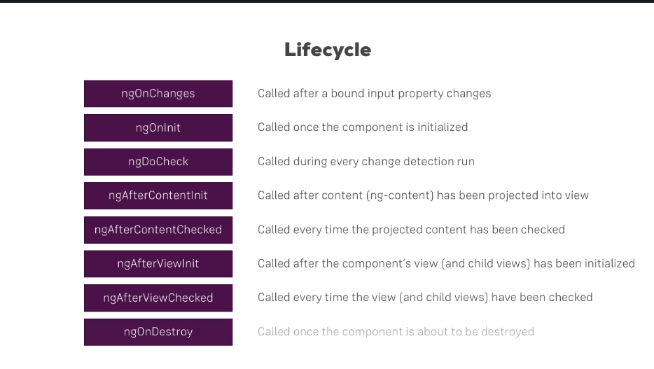

-ngDoCheck gets called whenever Angular checks for any changes. There are a lot of triggers to call this method
it is not a place where you should run some powerful code because that would cost you a lot of performance

Lifecycle hooks and Template access

-ngAfterViewInit will give the access to the template data all the hooks before that wont

Getting Access to ng-content with @ContentChild

@ContentChild (‘contentParagraph’) paragraph: ElementRef;
-we are actually sending the value trough ng-content to child component

Understanding Directives

Attribute Directives - are on the elements (they only change the element)
Structure Directives – are on the elements also but they also change the structure of
the DOM around this element
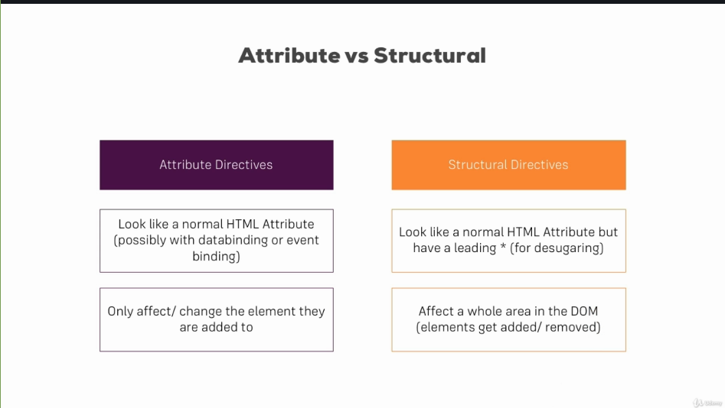

Creating a Basic Attribute Directive

We created folder with the new directive file inside:

import { Directive, ElementRef, OnInit } from ‘@angular/core’;

@Directive ({
selector: ‘[appBasicHighlight]’ (without [] it is selecting by element , with []
it will be recognized as attribute and it is
written without [])
})

export class BasicHighlightDirective implements OnInit {
constructor (private elementRef: ElementRef) {
}
}

ngOnInit() {
this.elementRef.nativeElement.style.backgroundColor= ‘green’;
}
If we are placing the attribute directive we are asking Angular to create that custom attribute and to deliver the results.
Inside of the directive constructor we have to place reference to the element where the custom directive is placed on ElementRef

We have to register the new Directive inside of the app.module.ts
@NgModule({
declarations: [
...
BasicHighlightDirective
],
...

and also we have to import the same Directive
import { BasicHighlightDirective } from ‘./basic-highlight/basic-highlight.directive’;

Using the Renderer to build a Better Attribute Directive

Accessing style of the Element is not good because it is accessing DOM directly. Renderer is used for Angular to render the template without the DOM

export class BetterHiglightDirective implements OnInit {

constructor (private elRef: ElementRef, private renderer: Renderer2) {

ngOnInit() {
this.renderer.setStyle(this.elref.nativeElement, ‘background-color’, ‘blue’);
}
}
}

In some circumstances if we don’t use renderer approach we could get some error messages . For example if we are running the app in the environment other then browser

Using HostListener to Listen to Host Events

export class BetterHighlightDirective implements OnInit {

constructor(private elRef: ElementRef, private renderer: RendererV2) {

}

ngOnInit () {

}

@HostListener(‘mouseenter’) mouseover(eventData:Event) {
this.renderer.setStyle(this.elRef.nativeElement, ‘background-color’, ‘blue’,
false ,false);
}
@HostListener(‘mouseleave’) mouseleave(eventData:Event) {
this.renderer.setStyle(this.elRef.nativeElement, ‘background-color’,
‘transparent’,false ,false);
}
}

Using HostBinding to Bind to Host Properties

@HostBinding (needs to be imported from angular core)

export class Better…
@HostBinding(‘style.backgroundColor’) backgroundColor: string= ‘transparent’

ngOnInit…
@HostListener…
this.backgroundColor = ‘blue’

and change transparent in the next HostListener to transparent(no need to use setStyle)
Binding to Directive Properties

export class BetterHigh…
@Input() defaultColor: string = “transparent”;
@Input() highlightColor: string = “blue”;
@HostBinding(style.backgroundColor) backgroundColor: string = this.defaultColor

ngOnInit…
@HostListener…
this.backgroundColor = this.highlightColor;

and change in next…

We can now dynamically change the colors from outside setting the properties on the element where new directive is used.
In this case that is the paragraph which background we are changing

<p appBetterHighLight [defaultColor]=”’yellow’” [highlightColor]=”’red’”>

Nisam zapisao kako se pravi alias na selektoru. Nesto se direktiva stvavi u uglaste zagrade pa se stavi argument unutar @Input

What Happens Behind the Scenes on Structural Directives

* star is actually means <ng-template [ngIf]=”!onlyOdd”>
<div>
<li>
...
</li>
</div>
</ng-template>

* is actually transforming this code to less code to write

Building a Structural Directive

export class UnlessDirective {
@Input() set appUnless(condition: boolean){
if(!condition) {
this.vcRef.createEmbeddedView(this.templateRef);
}else {
this.vcRef.clear();
}
}
constructor(private templeteRef: TempleteRef<any>, private vcRef: ViewContainerRef>)
}

set in this case sets the value on any change
Unless directive here will be on <ng-template>. We are injecting access to the place and the document where we want to render
Also we need to register the directive inside app.module.ts

<div *appUnless = “onlyOdd”>
<li>…
</li>
</div>

Understanding ngSwitch

<div [ngSwitch]=”value”>
<p *ngSwitchCase=”5”>Value is 5</p>
<p *ngSwitchCase=”10”>Value is 10</p>
<p *ngSwitchCase=”100”>Value is 100</p>
<p *ngSwitchdefault>Value is Default</p>
</div>

Building and Using a Drop-down Directive

-We are creating this new directive as dropdown.directive.ts inside of the shared folder

@HostBinding isOpen = false;

@HostListener(‘click’) toggleOpen() {
this.isOpen = !this.isOpen;
}

If we want to dynamicaly add or remove the CSS class we are using HostBinding

What are Services ?

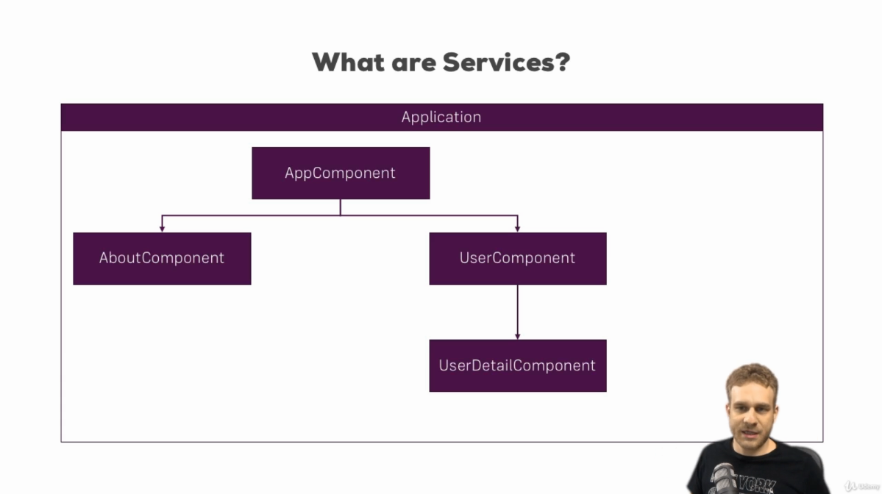
-Good use case for the service is duplication of code and data storage
-Providing data are typical use case for a service
-Service is just another piece in the Angular app , another class you can add which acts as a central repository. That central repository is used to centralize your code

Creating a Logging Service

Service is just a normal TS class and we don’t need the decorator

export class LoggingService {
logStatusChange(status: string) {
console.log(‘A server status changed , new status’ + status);
}
}

Hierarchical injector

Angular is offering us a great tool which give us access to our services Angular dependency injector

Dependency is something a class is depending on.
In our example new account component depends on the loggingService because we want to call a method in that service and the dependency injector simply injects this dependency, injects an instance of this class into our component automaticaly

template ?

TS TIP <> in Type Script this means that it is generic type

